**Creating and Working with IBM Cloud**

**Creating IBM Cloud account:**

     I have made an account on IBM Cloud which provides me a lot of features/Services which I can use for building my UI, chatbots, in built image recognition and many more, all for free in Lite account.

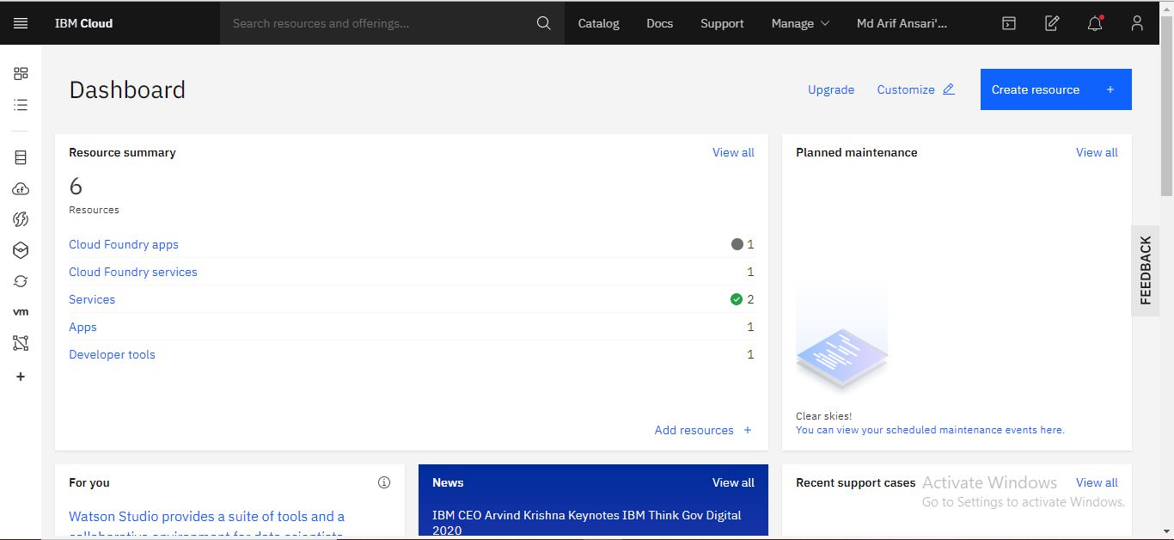

.

IBM is well known organization and it is giving chance to show their capabilities.

**Install Node-Red:**

    I have already installed Node-Red which is all free and it will be providing me complete tools to make an UI for my web app. All those UI can be made using flow diagram and this works on JASON format, which one can download easily too.

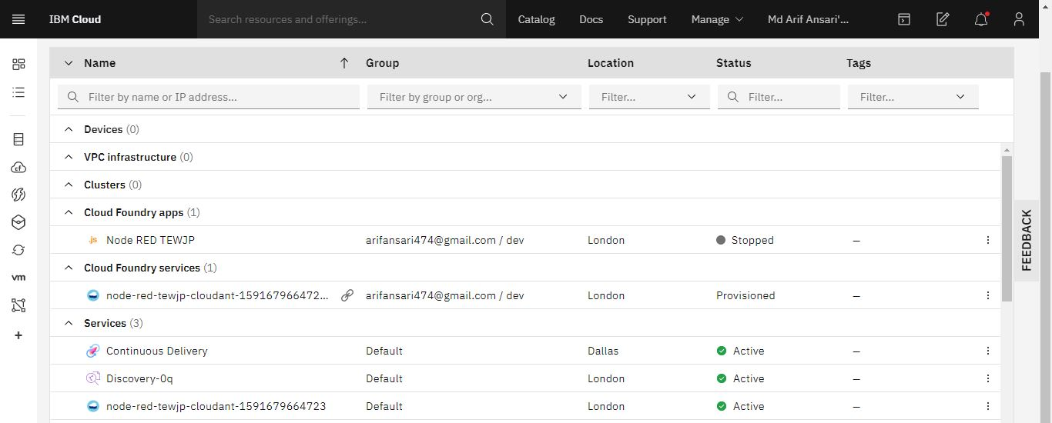

As it is visible that Node-Red is installed.

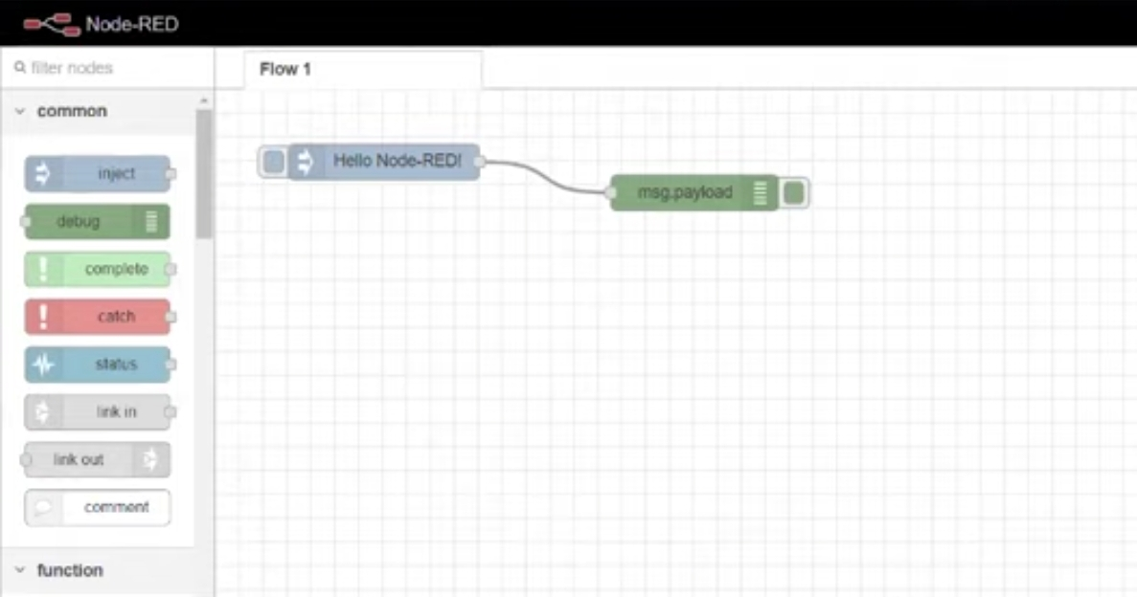

It is a basic node red flow which is always present after installing it for first time.

**Watson Studio :**

Watson Studio provides many features and one them is that it is helpful to provide python codes such as prediction model in Jupyter Notebook as seen below.

